ST0501 FRONT-END WEB DEVELOPMENT
INDIVIDUAL CA2 REFLECTION JOURNAL

Student Name: Chee Yu Yun Admin Number: P2608442
Class: DCS/FT/1A/05 Group No: Group 4

Objective :
This Reflection Journal requires you to critically analyze your CA2 project decisions, technical issues, and your responsible use of AI tools. Tutors are looking for depth of thought and examples that demonstrate understanding of your work.
Instructions:
- Answer all 3 parts below
- Total word count : 900-1200 words
- Use examples from your CA2 or class activities where relevant
- Submitted individually via BrightSpace.
- Attach your AI prompt logs using the Academic Integrity Declaration link (available in BrightSpace) in Appendix, this will not be included in the wordcount.

Part 1: Reflection on Styling Frameworks & Interactivity
- What changes are made to the original plan? Why are the changes necessary? And what impact do they cause e.g on the website, user experience, performance etc?
- Analyze the trade-offs between using a front-end styling framework (e.g., Bootstrap/Tailwind) and writing custom CSS in your project. How did your choice affect the efficiency, design flexibility, or maintainability of your website?
- Evaluate one interactive feature (e.g., form validation, DOM update, dynamic menu) you implemented: How well does it improve user experience? If you had to enhance it further, what changes would you make and why?

Word Count Suggestion: 250-450 words. (Write your answer here)

I changed our website by using Bootstrap. These changes made the site more responsive, easier to navigate, and improved the overall user experience. Each destination—Chengdu, Guilin and Yunnan now has its own dedicated CSS and JS file on top of Bootstrap 5 and Bootstrap Icons. A shared navigationBar.css/ navigationBar.js and footer.css/ footer.js maintain a consistent header and footer across all pages. This was important because each page needed a unique visual identity. Chengdu focuses on a spice level picker and hotpot builder. Guilin emphasizes a scroll telling river journey and Yunnan features a click to unfold cultural panel. The result is a site that feels personalized for each destination while still using Bootstrap for a quick and responsive layout. This approach does require loading multiple asset files for each page.
We chose Bootstrap because it saved our time and offered ready-made components like the navigation bar and grid system. Compared to custom CSS, Bootstrap allows for faster development but offers less design flexibility. Therefore, we used custom CSS to give the website a more unique look. Each page has its own prefixed custom CSS for elements that Bootstrap doesn't include by default, such as the timeline with a scroll-linked progress fill, spice-card flip states and SVG draw in animations. This combination allowed us to benefit from Bootstrap's development speed while maintaining full design flexibility. But this means that some of the interactive patterns are repeated across script files instead of being shared in a single module.
Our main interactive feature is form validation, which checks if users fill in the required fields before submitting. This reduces errors and enhances user experience. In addition to form validation, we created destination-specific features, like the spice level picker on the Chengdu webpage. This lets users dynamically see dish cards re-render based on their selection. If we could further improve our interactive features, we would add real-time validation to provide feedback as users type. We would also implement smooth height transitions when dish cards expand and include proper aria-expanded attributes to enhance accessibility for screen readers.

Part 2: Reflection on JavaScript & DOM Interactivity
- What changes are made to the original plan? Why are the changes necessary? And what impact do they cause e.g on the website, user experience, performance etc?
- Which JavaScript feature you added (e.g., image gallery, menu toggle, validation) made the biggest impact on your website’s user experience? Why?
- Think about the form your created in CA2 or practiced in class: What makes a form easy or hard for users to complete? What is one improvement you would suggest making a form more user-friendly, and why?

Word Count Suggestion: 250-450 words. (Write your answer here)

We had a plan to make each destination page with static content and basic navigation. We did something different. We made different experiences. The Chengdu page has a filter that helps you choose how spicy you like your food and a mini-game where you can build your hotpot. The Guilin page has a storytelling feature that changes the picture and shows users where they are in the story as you scroll down. The Yunnan page has a panel that opens when you click on it and shows users more information about the culture. It also has fun animations.
We had to do it this way because just having a lot of text on the page would be boring. Breaking it up into pieces that you can interact with makes it easier to understand. This way is more fun. Helps users to understand the information better. It is also more complicated. Each page has to do a lot of things at the time like animate pictures and change text. This means we had to test it a lot to make sure everything worked correctly.
The Guilin river journey part was the interesting. As users scroll down the page the big picture will changes. This makes it feel like the user is taking a journey down the river. It is different from the pages like Chengdu's spice picker or Yunnan's panels because it changes as users scroll. This makes the story feel more real and exciting.
When users are filling out a form it is easy if the labels are clear and it tells users what they need to fill out. It is hard when they do not know what did wrong until they submit it or when the error messages are not helpful. One thing that would make it better is if it checked each field as type of just when you submit it. This way you can fix mistakes away and it makes the process faster and less frustrating. The Chengdu page and the Yunnan page and the Guilin page all have forms that could be improved in this way. Filling out forms, on the Chengdu page or the Yunnan page or the Guilin page would be easier if they had this feature.

Part 3: Reflection on AI Usage and Evidence of Understanding

- Analyze your use of AI during this project: Which specific problem or task did AI help you with, and why did you choose to use AI for it?
- Choose one example where you used AI to help with coding for your website. Show the original AI-generated snippet and your modified version. Explain what you changed and why. How did your changes make the code better or fit your project needs?

Word Count Suggestion: 250-450 words. (Write your answer here)

During this project, I used AI to help me with coding tasks for my Chengdu travel website. AI was mainly useful when I was unsure how to add certain features or structure my HTML, CSS, and JS code. I use AI because it helped me understand coding problems faster and generate some examples that easy to understand for me to study and modify. However, I didn’t fully trust and copy everything from AI. I checked the code, tested it on my website and changed parts of it to match my project requirements.

One example was adding images to the landmark cards on my website. The original AI-generated CSS used simple gradient backgrounds:
.cd-img-teahouse{background:linear-gradient(135deg,#6B4A34,#3B2517);}
.cd-img-panda{background:linear-gradient(135deg,#4A5D3A,#28321F);}
I modified the code to use my own images:
.cd-img-teahouse{
background-image:url("../images/Chengdu/peopla\'s\ park.jpeg");
background-size:cover;
background-position:center;
}
.cd-img-panda{
background-image:url("../images/Chengdu/panda\ base.jpeg");
background-size:cover;
background-position:center;
}
I made these changes because I wanted my website to use real Chengdu images instead of only coloured backgrounds. I also used background-size: cover so that the images would fill the image area properly without looking stretched. The background-position: center helped keep the main part of each image visible.
This change made my website more visually attractive and more relevant to the Chengdu theme. It also showed that I understood how CSS background images work instead of only copying AI-generated code. I learned that AI can help me solve coding problems, but I still need to understand, test, and modify the code so that it fits my own project.

Appendix (e.g AI outputs or evidences you would like to include, this will not be included in the wordcount)
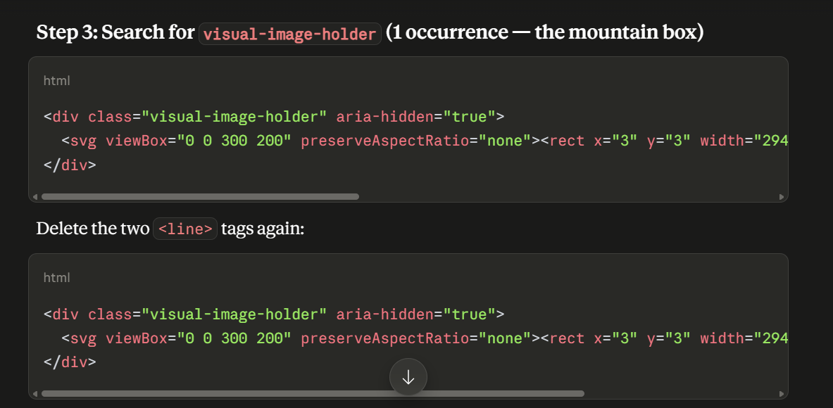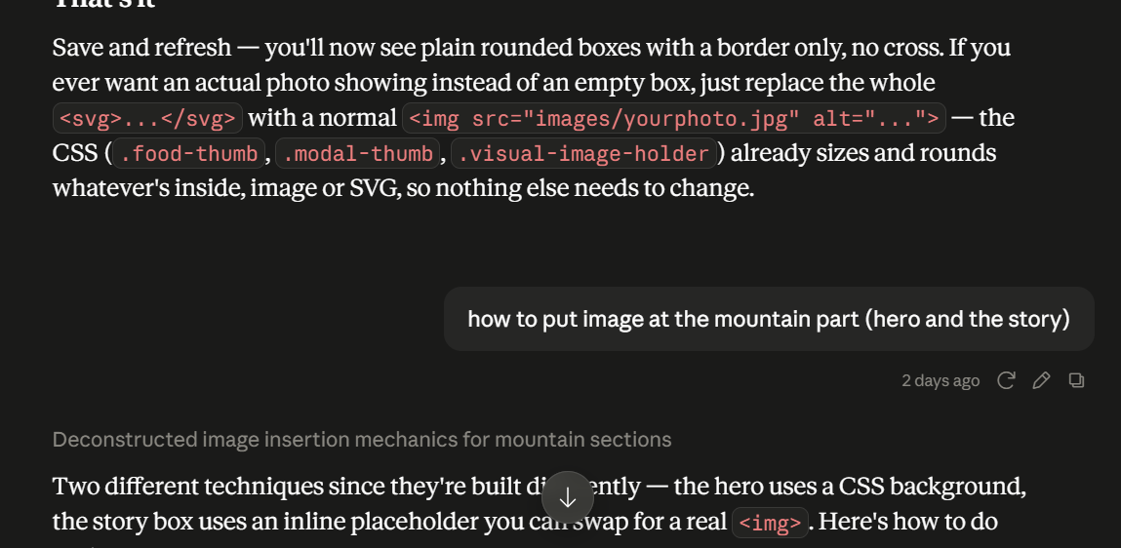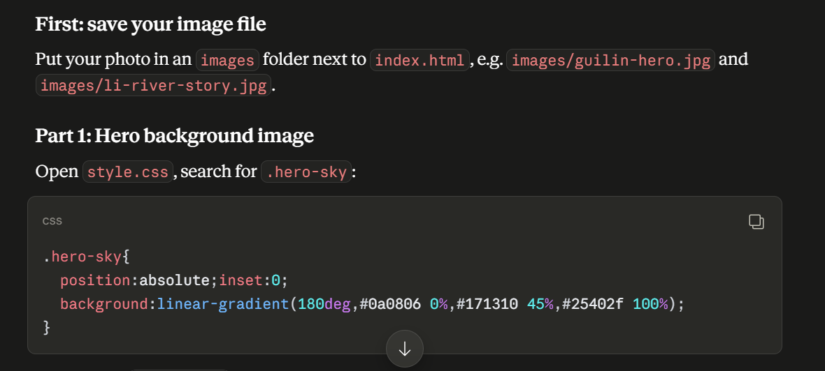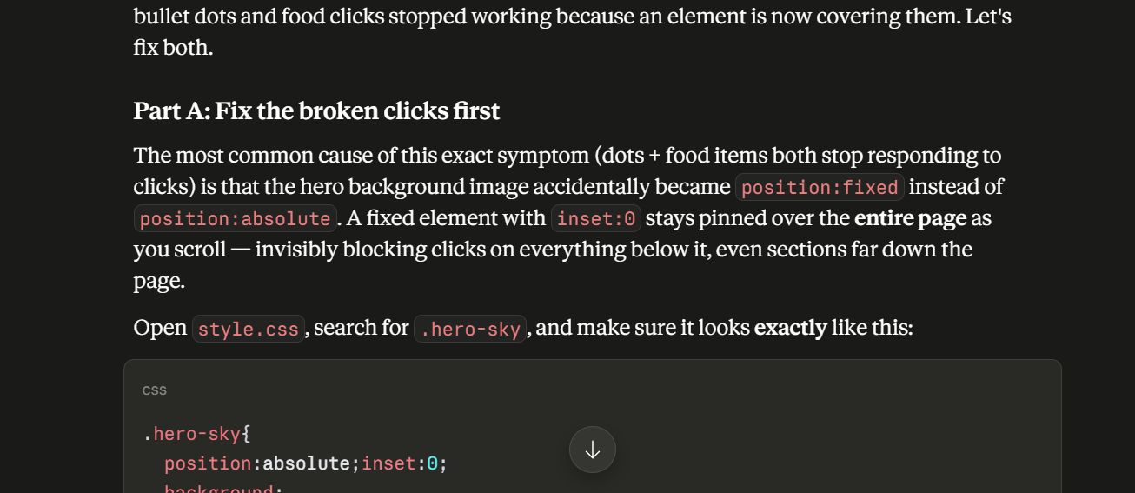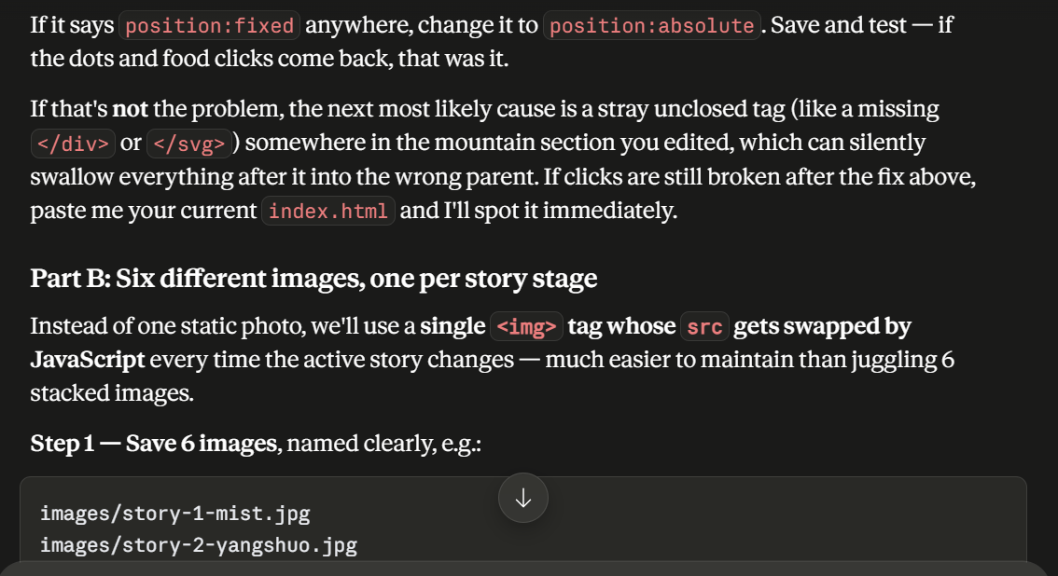
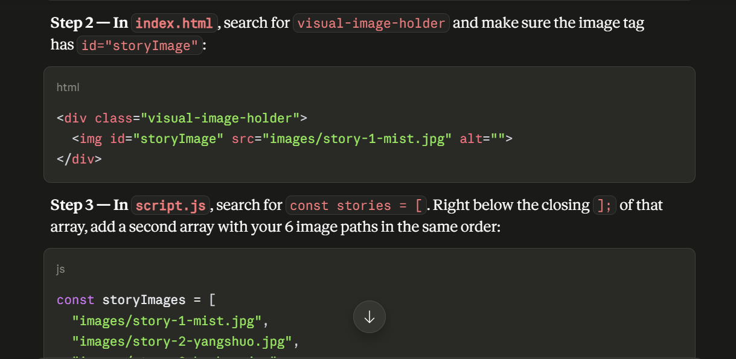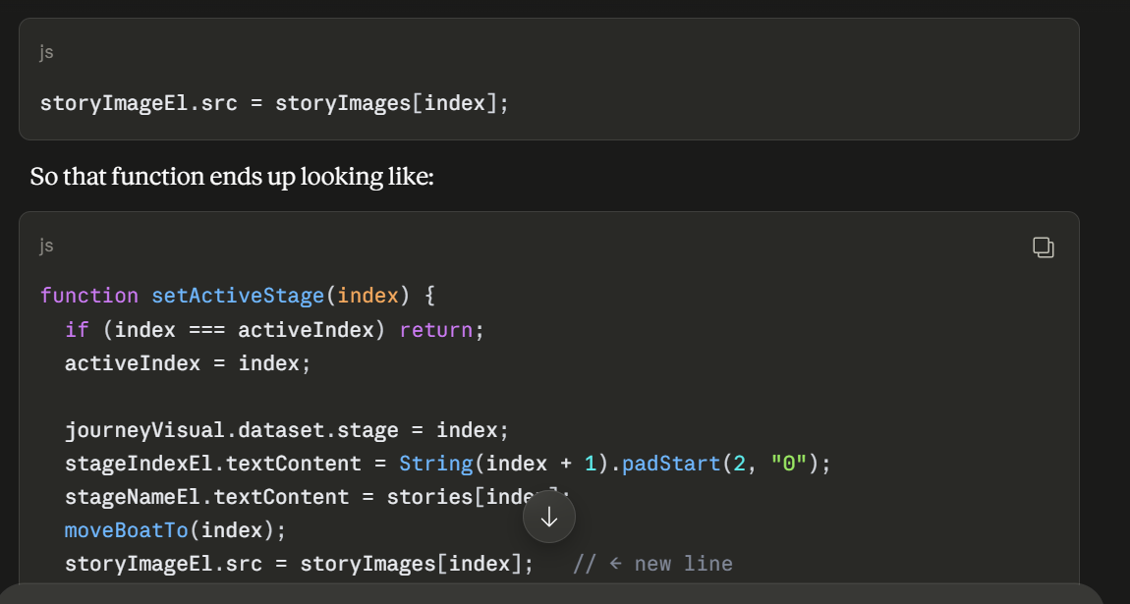

~~ The End ~~

